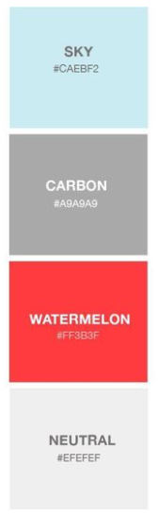

Sky: #CAEBF2

Carbon: #A9A9A9

Watermelon: #FF3B3F

Neutral: #EFEFEF